How to setup the structure:

Input Directory orderdata:

- MacBook Pro van Daniel
- Macintosh HD
- Gebruikers
- danielvanwilligenmbp
- Documenten
- Stepdata

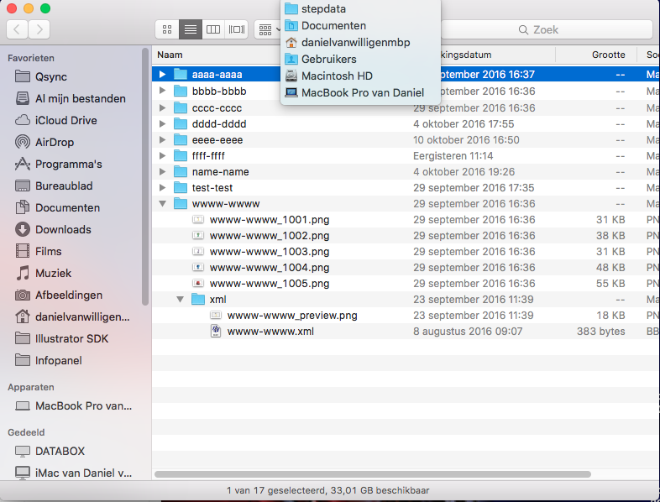

Output Directory orderdata:

- MacBook Pro van Daniel
- Macintosh HD
- Gebruikers
- danielvanwilligenmbp
- Documenten
- Stepdataoutput

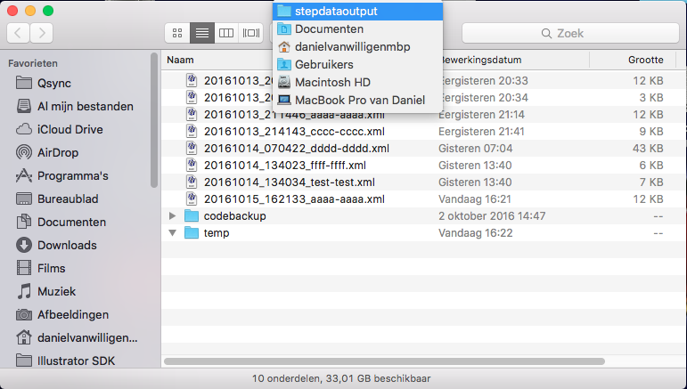

Paths can be changed in SetPath.java. In this java document it’s also possible to change the resources path for the GUI.

